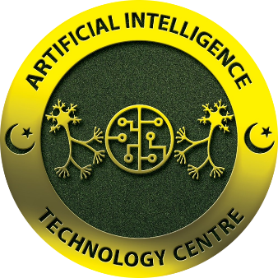

September 6, 2024

NCP (AITec)

Internship report

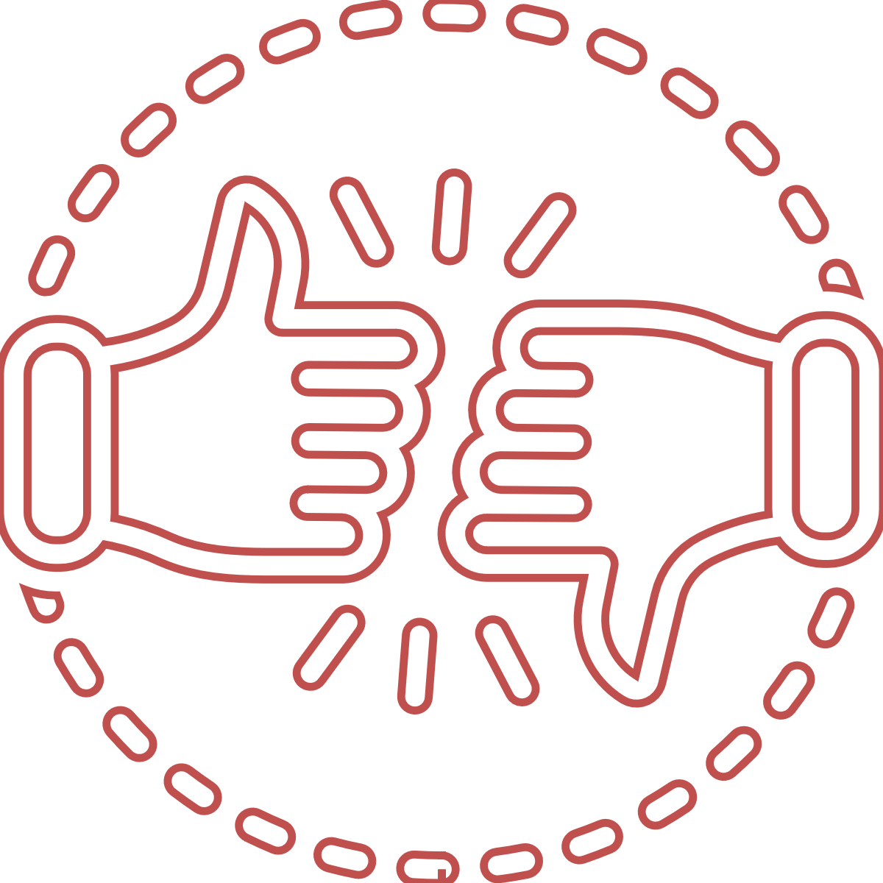

Reg.no: Int-1221/AITeC

Name: Muhammad Saleh

Internship duration: 8 weeks

Contents

**Introduction** 2

**Week 1** 3

**Week 2** 4

**Week 3** 5

**Week 4** 6

**Week 5** 7

**Week 6** 8

**Week 7** 9

**Week 8** 10

**Conclusion** 11

# **Summary**

This report provides a comprehensive overview of my internship experience at NCP (National Centre for Physics. This internship has enhanced my understanding of AI and equipped me with valuable skills that will benefit my future events.

Throughout this report, I will explore the key experiences and actions I gained during my internship. I will discuss the specific projects I worked on, the challenges I faced, and the strategies I engaged to overcome them. Additionally, I will highlight the skills and knowledge I acquired, such as (Communication skills, Problem-solving skills, and many more).

This report aims to provide a detailed description of my internship journey, representing my ability to apply theoretical knowledge to practical situations and showcasing my potential to contribute meaningfully to the field of AI.

The project is the based-on 3D reconstruction from 2D images. The task is to generate the 3D models through the images of different objects. It is a detection system used to learn the features of the object in machine learning that generates the model using the algorithm of GAN and IWGAN. This model lead to our required output of the task that I have going to do.

# **Week 1**

In the first week they have assigned me a task on creating a model of a building in unity. With materials and structures used in the model. The first task was working on AR core features and their uses in the unity framework. The second task is to create a model of 2D map of a blueprint and their related 3D model. We have done in manually through Canva for 2D mapping and for 3D unity are used. Now the third task to train the model to detect the image to form a 3D model in unity.

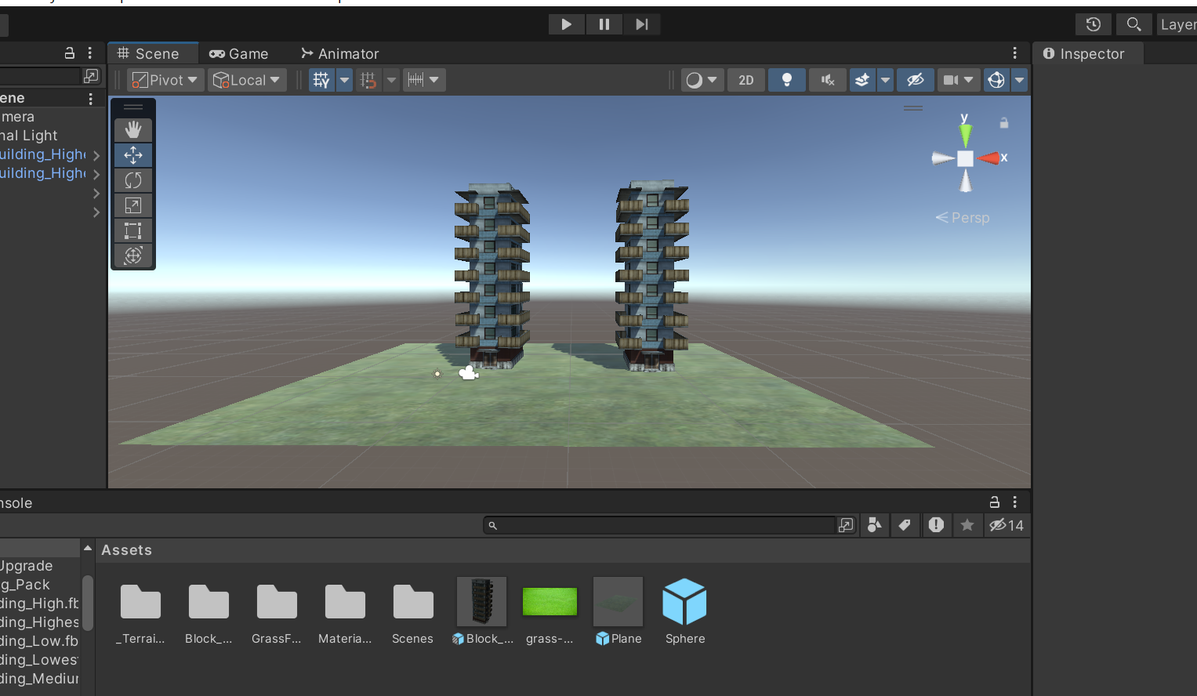

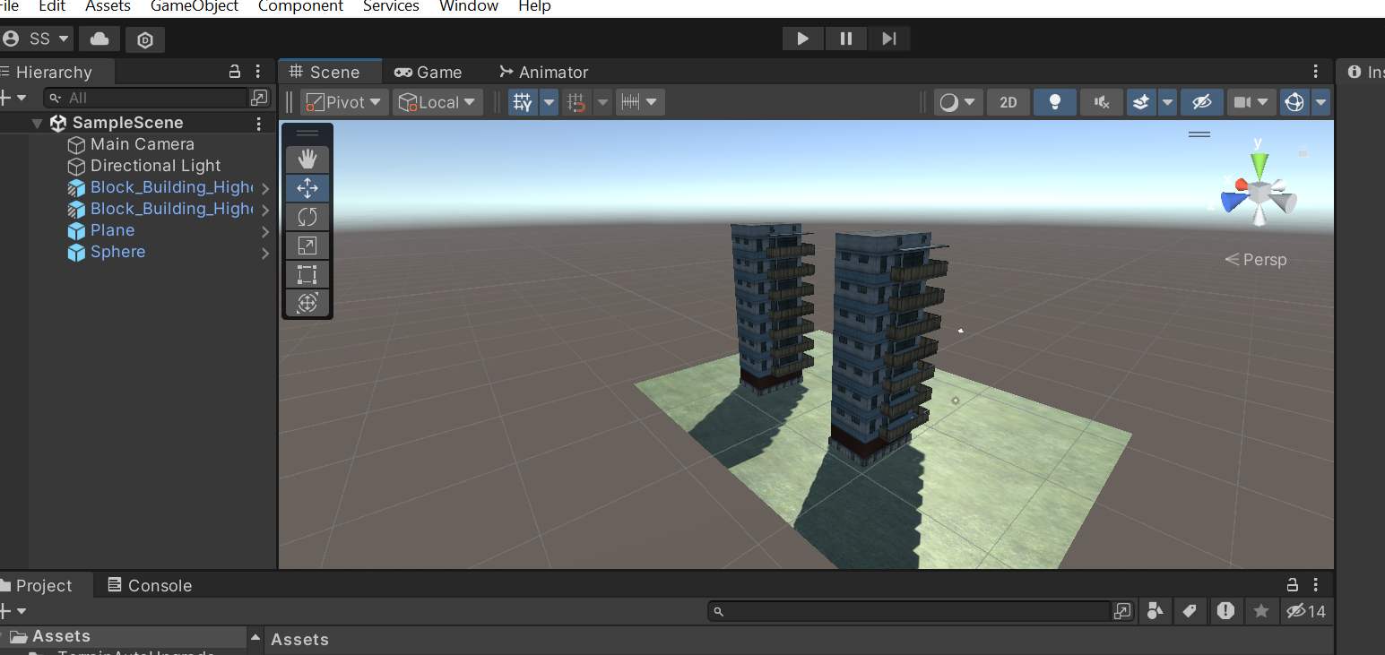

# **Week 2**

Now the next task was in computer vision on the base of object detection of an object (person). To achieve the target, I have learned the working of OpenCV through python. The task is to train the model of class for Person, for learning the behaviour of the technology to detect different objects through pictures and video. And also, be used a pretrain model known as YOLOv8. It is a pretrained model for detection. To prepare our own model, it requires training with large number of samples to educate the machine that this feature of object is called a person. In this project consumes time taken due to large dataset to train and correcting the bugs that I was facing. The task is now fully operational. And the other part of OpenCV like tracking and segmentation requires the same procedure as detection.

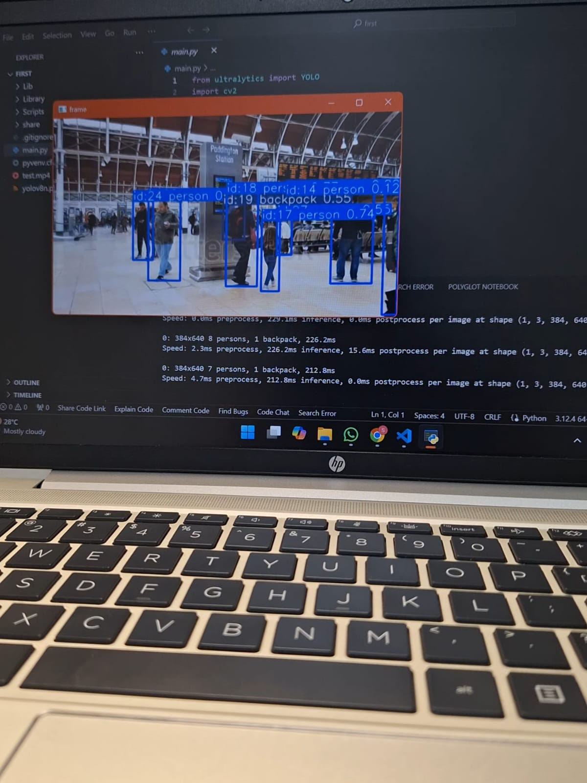

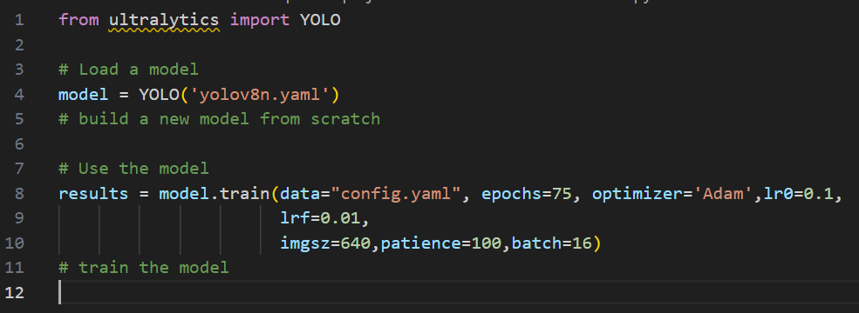

# **Week 3**

The next task in OpenCV is to train the model in the format of segmentation. From any video or in real time detection of the code. It includes training the model than I detect the person. Training the model takes a lot of time to meet our requirements and accuracy of model.

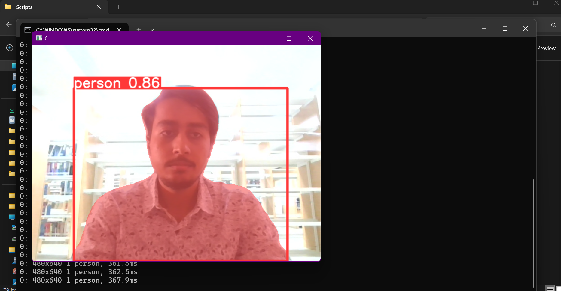

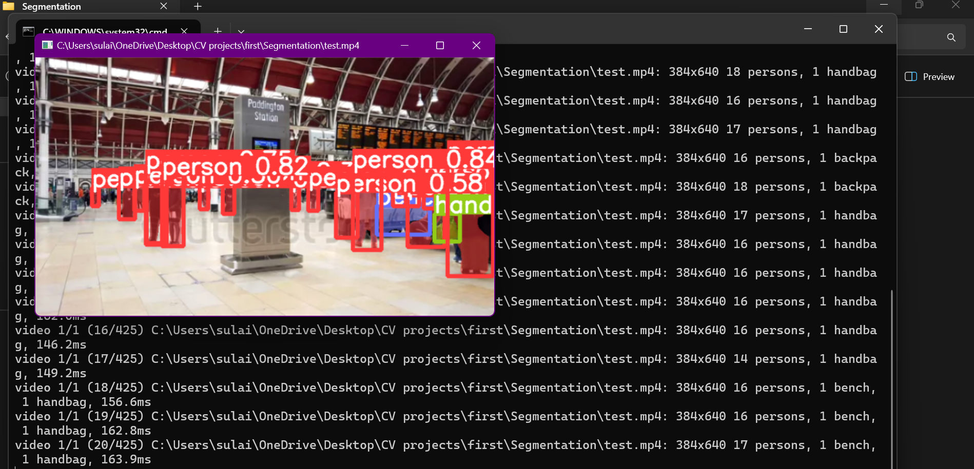

# **Week 4**

In this week, I prepare a tracking part in OpenCV that track the number of ID that comes to the frame. Each person has given an ID to mark the person to detect. If the person comes out the frame and come given in the frame then the ID of his previous becomes change due to new input in the screen. To achieve this result, the model will be trained from video or large number of datasets of images. Tracking in OpenCV is widely used to follow the movement of objects within a video or real-time feed. It enables the identification and continuous monitoring of an object's position as it moves across frames, making it essential for motion analysis, where patterns and behaviours of moving entities, such as people, vehicles, or animals, are studied. It is also a key component in augmented reality, where virtual objects must align and move consistently with real-world objects. In human-computer interaction, tracking facilitates gesture recognition and interaction, allowing systems to respond to hand or body movements, which is particularly useful in creating intuitive and immersive experiences.

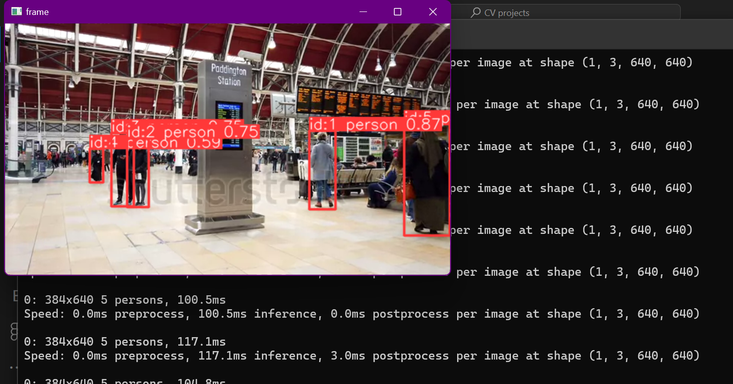

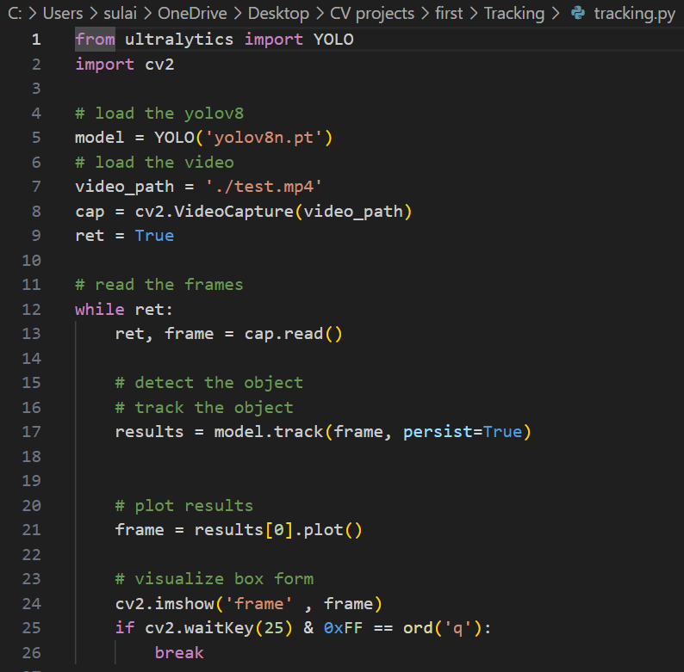

# **Week 5**

In week 5, I have discovered a new model which is used for displaying 3D model in real-time. To make the work done, it requires an edge detection with the image that you want to deploy if a particular image appear in front of camera. Then it matches the image features and the source features that the image is same or not. If the image is same than the camera will display the model of any 3D object for example a chair. And the technology used to display the model is using through Augment Reality. This task is the part of 3D reconstruction model from image to model object.

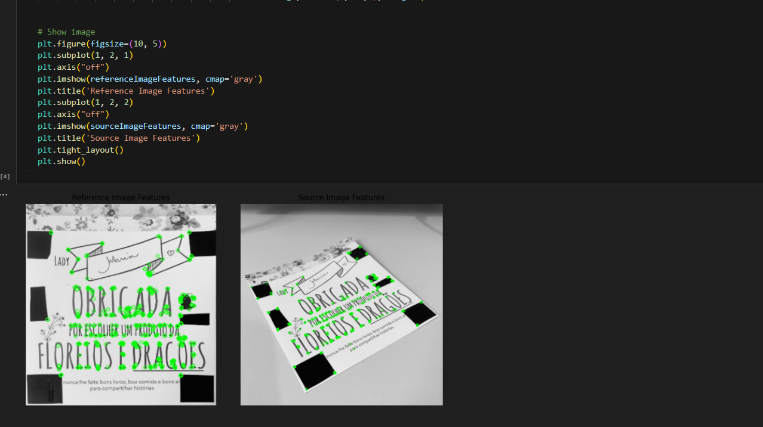

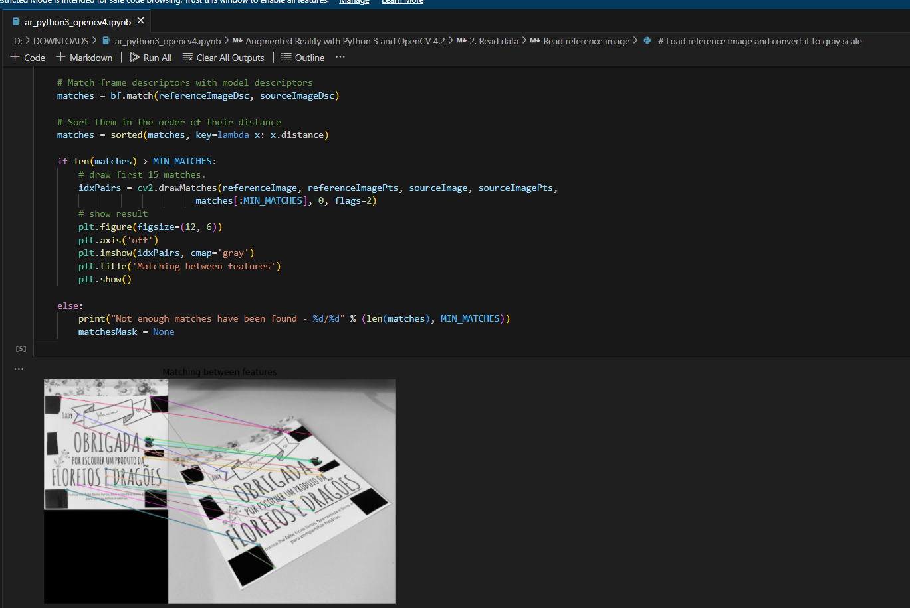

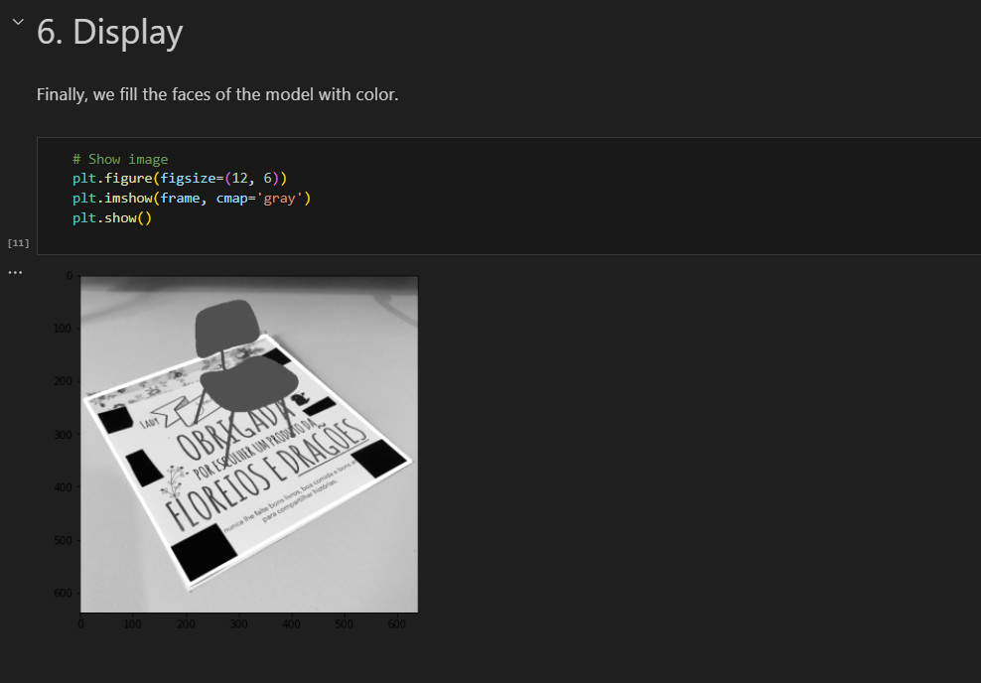

# **Week 6**

In week 6, the task is to reconstruct a 2D images into 3D model. The model to get the nearest results is to run the epoch about 500 times to get the result. Which need a GPU power to run the program. Training the model requires dataset of images of chair with number of angles and positions to study the real chair features to the machine learning model. This model can be view in MeshLab or Blender for 3D view. MeshLab are basically used for view and editing the model with the respected features such as scaling, cutting, edge correction, rendering, reconstruction, texture mapping, exporting and converting formats. You can generate UV maps, which are essential for applying 2D textures onto 3D surfaces. MeshLab includes a scripting feature that allows users to automate repetitive tasks or apply the same process across multiple files.

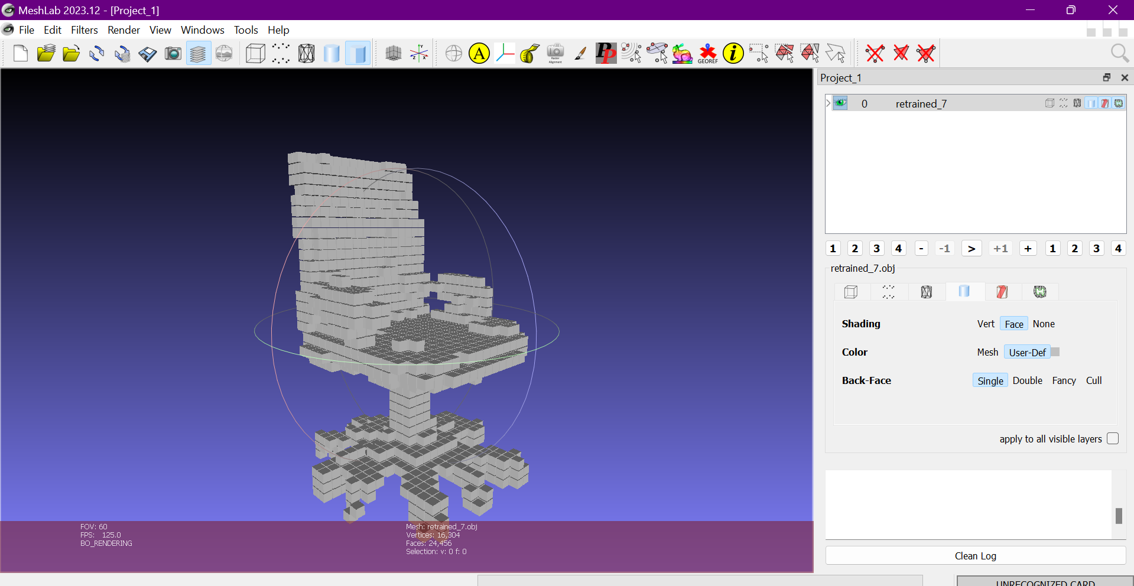

# **Week 7**

In week 7, I have entered in the Mobile application development for our project. I have designed a prototype of our application with the help of Figma. Figma is a powerful design tool known for its both individual designers and collaborative teams. This feature is complemented by its cloud-based platform, which ensures that projects are always up-to-date and accessible from any device without the need for constant file syncing. Figma also provides robust design tools, including vector editing, prototyping, and design systems management, allowing users to create, test, and iterate designs efficiently. The integration with plugins and third-party tools further enhances its functionality, making it a flexible choice for UI/UX design, wireframing, and creating interactive prototypes. These core features make Figma a comprehensive and collaborative tool that streamlines the design process from conception to final delivery. And also, you test your UI/UX design in your mobile to see the working experience in real-time. Below are basic design and UX design of application.

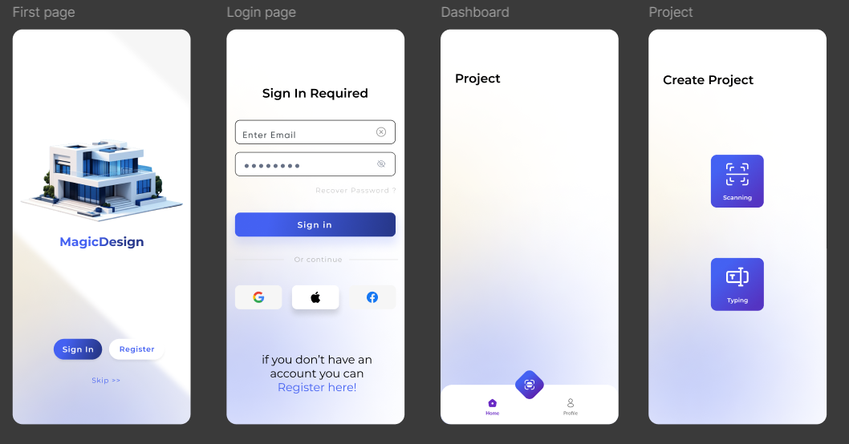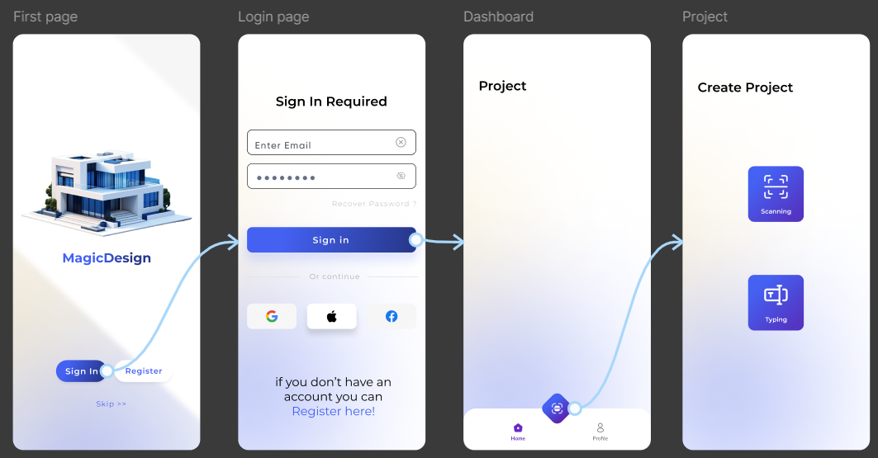

# **Week 8**

My last week working in NCP, is to implement the prototype design into Mobile application. In this task I have face a challenge in android studio. Such as languages used in the android studio is Kotlin, mostly are some java and xml extension are being used also, it difficult to handle multiple languages at the same time. The reason is all the languages are link together with different functionality in the system. XML file is used for making user interface.

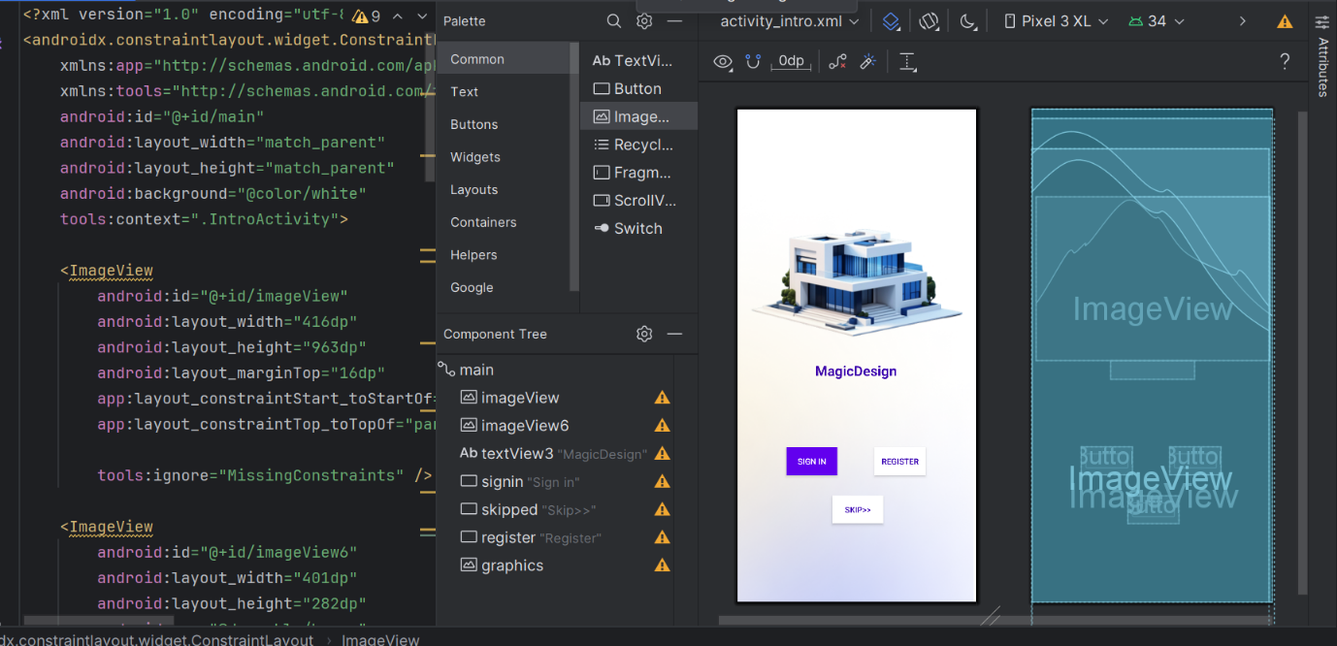

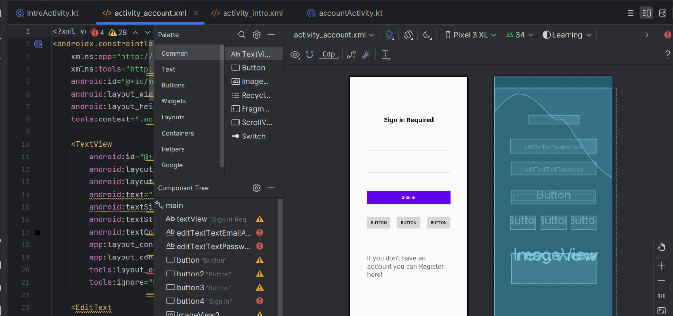

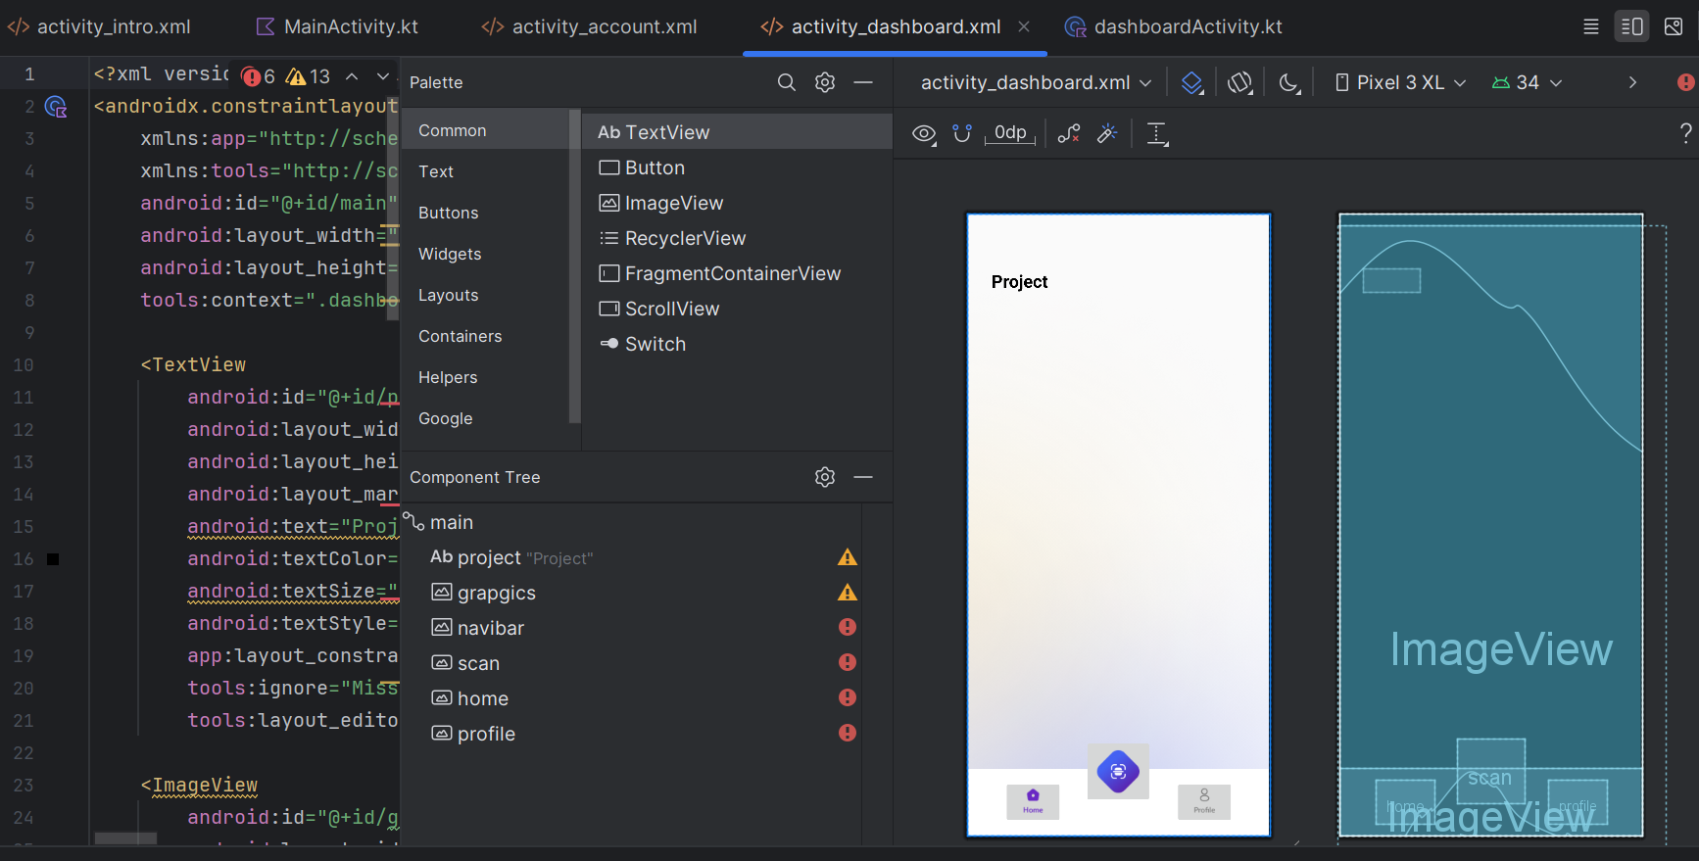

# **Conclusion**

This internship gives me a number of experiences in my career that make me more confident in the upcoming challenges in the field of development and login building. Hence, a great experience been shared in NCP in various field like machine learning, Computer vision, image reconstruction and mobile application design with Android studio.